SVKM’s NMIMS
Mukesh Patel School of Technology Management & Engineering
Computer Engineering Department
Program: B.Tech Integrated Sem V

Course: Basic Data Structures
2024-2025
Experiment No.04
A.1 Aim:
To study and implement concept of Stack data structure.

A.2 Prerequisite:
1.Knowledge of different operations performed on Stack data structure
2. Fundamental concepts of C\C++.

A.3 Outcome:
After successful completion of this experiment students will be able to
- Identify the need of appropriate selection of data structure
- Identify the steps of stack data structure selection.
- Implement stack data structure to solve the given problem
- Enlist the applications of stack data structure.

A.4 Theory:
A.4.1. Introduction of Stack
Stack is a linear data structure which follows a particular order in which the operations are performed. The order may be LIFO (Last in first out) or FILO (First in last out).
The functions performed on stack are:
- Push: Adds an item in the stack. If the stack is full, then it is said to be an overflow condition.
- Pop: Removes an item from the stack. The items are popped in the reversed order in which they are pushed. If the stack is empty, then it is said to be an underflow condition.
- Peek: Returns the top most element from the stack.
Applications of Stack:
- Balancing of symbols
- Infix to postfix\prefix conversion
- Redo-undo features at many places like editors, photoshop
- Forward and backward feature in web browsers
A.5 Procedure/Algorithm:
A.5.1:
TASK 1:
Write a program to implement ADT of Stack.
TASK 2:
The organization structure of “ABC Pvt. LTD” is given as per joining order. The company is in crisis and wants to start lay off. The employee who joined last is fired first. Implement the suitable data structure and display the order in which the company will fire employees.
Employee id | Order of joining
101 | 1 | (joined first)
102 | 2
107 | 3
108 | 4
111 | 5
112 | 6 | (joined last)

PART B
(PART B : TO BE COMPLETED BY STUDENTS)
(Students must submit the soft copy as per following segments within two hours of the practical. The soft copy must be uploaded on the Blackboard or emailed to the concerned lab in charge faculties at the end of the practical in case the there is no Black board access available)

Roll No.: C172 | Name: Parva Gaglani
Class : D | Batch :D2
Date of Experiment: 6/08/24 | Date of Submission: 6/08/24
Grade : | Time of Submission:
Date of Grading:

B.1 Software Code written by student:(Task 1)
(Paste yourcode completed during the 2 hours of practical in the lab here)
Task1:
#include <iostream>
using namespace std;

// Global variables for stack operations
int stack[100], n = 100, top = -1;

// Function to push a value onto the stack
void push(int val) {
if (top >= n - 1) {
cout << "Stack Overflow" << endl;
} else {
top++;
stack[top] = val;
}
}

// Function to pop a value from the stack
void pop() {
if (top <= -1) {
cout << "Stack Underflow" << endl;
} else {
cout << "The popped element is " << stack[top] << endl;
top--;
}
}

void display() {
if (top >= 0) {
for (int i = top; i >= 0; i--) {
cout << stack[i] << " ";
}
cout << endl;
} else {
cout << "Stack is empty" << endl;
}
}

void peek() {
if (top <= -1) {
cout << "Stack Underflow" << endl;
} else {
cout << "The element on top is: " << stack[top] << endl;
}
}

int main() {
int choice, val;

cout << "1) Push in stack" << endl;
cout << "2) Pop from stack" << endl;
cout << "3) Display stack" << endl;
cout << "4) Peek from stack" << endl;
cout << "5) Exit" << endl;

do {
cout << "Enter choice: " << endl;
cin >> choice;

switch (choice) {
case 1: {
cout << "Enter value to push: ";
cin >> val;
push(val);
break;
}
case 2: {
pop();
break;
}
case 3: {
display();
break;
}
case 4: {
peek();
break;
}
case 5: {
cout << "Exiting!" << endl;
break;
}
default: {
cout << "Invalid choice!" << endl;
break;
}
}
} while (choice != 5);
return 0;
}

Task2:
#include <iostream>
using namespace std;

int stack[6], top=-1;

void push(int item)
{
if (top>=5)
{
cout<<"Error! Overflow.";
}
else
{
top+=1;
stack[top]=item;
cout<<item<<" pushed successfully."<<endl;
}
}

int pop()
{
if (top==-1)
{
return 0;
}
else
{
return stack[top];
}
}

int peek()
{
if (top==-1)
{
return 0;
}
else
{
return stack[top];
}
}

void display()
{
if (top==-1)
{cout<<"\nError! Stack is empty."<<endl;}
else
{
int i;
cout<<"Stack elements: ";
for (i=0;i<=top;i++)
{
cout<<stack[i]<<" ";
}
cout<<endl;
}
}

int main()
{
int choice, x, order[6], i=0;

start:
cout<<"\nAvailable Actions: ";
cout<<"\n 1. Hire \n 2. Layoff \n 3. Display \n 4. Exit"<<endl;
cout<<"Enter your selection: ";
cin>>choice;
switch(choice)
{
case 1:
cout<<"\nEnter employee id: ";
cin>>x;
push(x);
goto start;

case 2:
if(pop())
{
cout<<"Order of firing: ";
int max=top;
for (int i=0;i<=max;i++)
{
/*cout<<i<<" "<<top;*/
order[i]=pop();
cout<<order[i]<<" ";
top-=1;
}

goto start;
}
else
{
cout<<"Error in popping element!"<<endl;
goto start;
}

case 3:
display();
goto start;

case 4:
cout<<"\nExiting.";
break;

default:
cout<<"\nError! Please select correct action."<<endl;
break;
}
}

TASK 3
Code:
#include <iostream>
using namespace std;

char stack[10];
int top = -1;

void push(char item)
{
if (top >= 9)
{cout<< "Error! Overflow." <<endl;}
else
{
top += 1;
stack[top] = item;
}
}

char pop()
{
if (top == -1)
{return 0;}
else
{return stack[top--];}
}

char peek()
{
if (top == -1)
{return 0;}
else
{return stack[top];}
}

bool areBalanced(const string& equation)
{
for (char ch : equation)
{
if (ch == '(' || ch == '{' || ch == '[')
{
push(ch);
}
else if (ch == ')' || ch == '}' || ch == ']')
{
if (top == -1)
{
return false;
}
char topElement = pop();
if ((ch == ')' &&topElement == '(') ||
(ch == '}' &&topElement == '{') ||
(ch == ']' &&topElement == '['))
{
return true;
}
}
}
return top == -1;
}

int main()
{
string equation;
cout<< "Enter an equation: ";
cin>>equation;

if (areBalanced(equation))
{
cout<< "All parentheses are closed." <<endl;
}
else
{
cout<< "There are unclosed parentheses." <<endl;
}

return 0;
}

TASK 4:
#include <iostream>
#include <cstring>
using namespace std;

int precedence(char op) {
switch(op) {
case '+': return 1;
case '-': return 1;
case '*': return 2;
case '/': return 2;
case '%': return 2;
case '^': return 3;
default: return 0;
}
}

bool isop(char ch) {
return ch == '+' || ch == '-' || ch == '*' || ch == '/' || ch == '^';
}

void infix_to_postfix(const char infix[], char postfix[]) {
char stack[100];
int top = -1;
int k = 0;

int len = strlen(infix);

for(int i = 0; i<len; i++) {
char ch = infix[i];

if ((ch>= '0' &&ch<= '9') || (ch>= 'A' &&ch<= 'Z') || (ch>= 'a' &&ch<= 'z')) {
postfix[k++] = ch;
}
else if (ch == '(') {
stack[++top] = ch;
}
else if (ch == ')') {
while (top != -1 && stack[top] != '(') {
postfix[k++] = stack[top--];
}
top--; // Pop the '('
}
else if (isop(ch)) {
while (top != -1 && precedence(stack[top]) >= precedence(ch)) {
postfix[k++] = stack[top--];
}
stack[++top] = ch;
}
else {
cout<< "Invalid character in infix expression!";
return;
}
}

while (top != -1) {
postfix[k++] = stack[top--];
}

postfix[k] = '\0';
}

int main() {
const int MAX = 100;
char infix[MAX];
char postfix[MAX];

cout<< "Enter infix expression: ";
cin.getline(infix, MAX);

infix_to_postfix(infix, postfix);

cout<< "Postfix Expression: " << postfix <<endl;

return 0;
}

B.2 Input and Output: (Task 1)
(Paste your program input and output in following format, If there is error then paste the specific error in the output part. In case of error with due permission of the faculty extension can be given to submit the error free code with output in due course of time. Students will be graded accordingly.)

Task1:

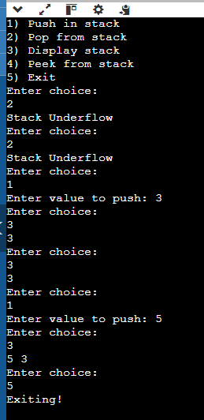
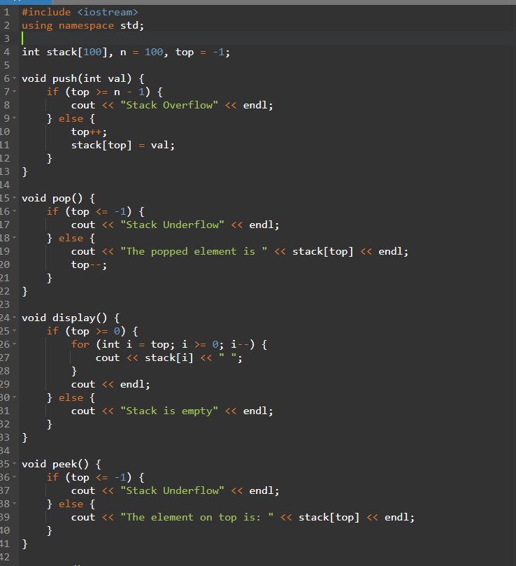
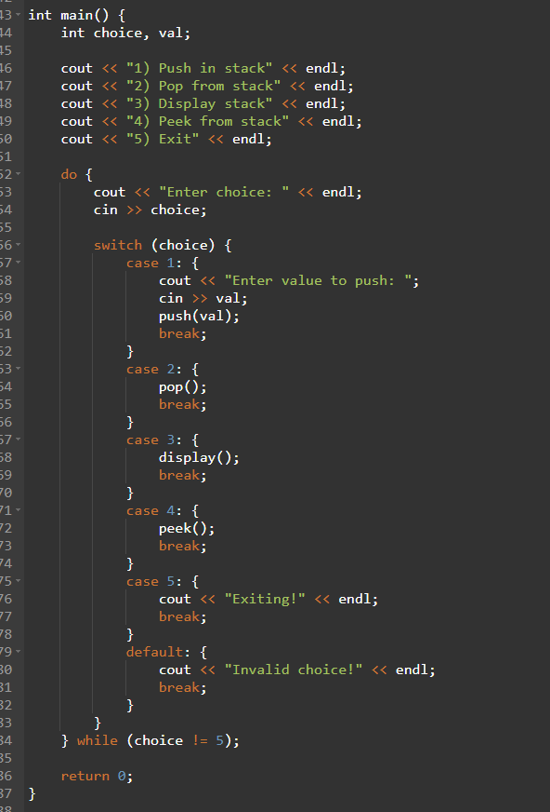

Task2:
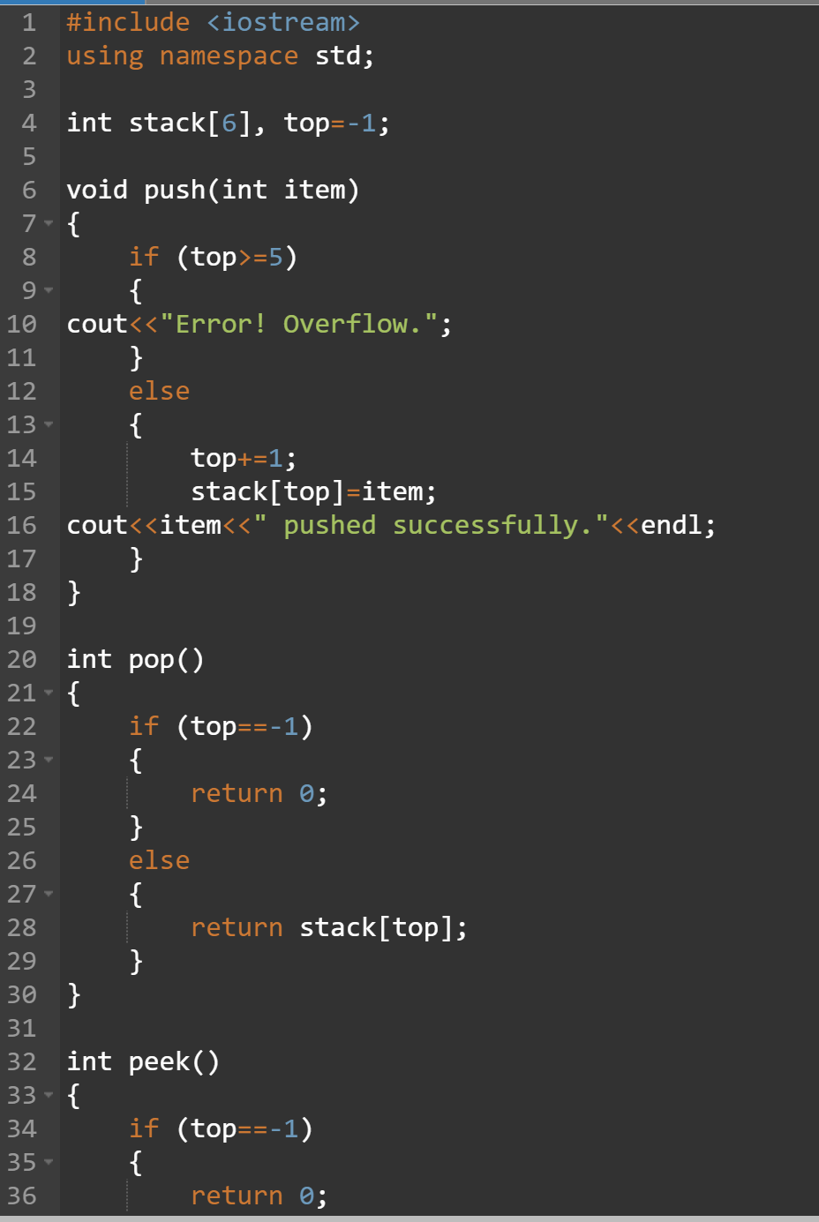

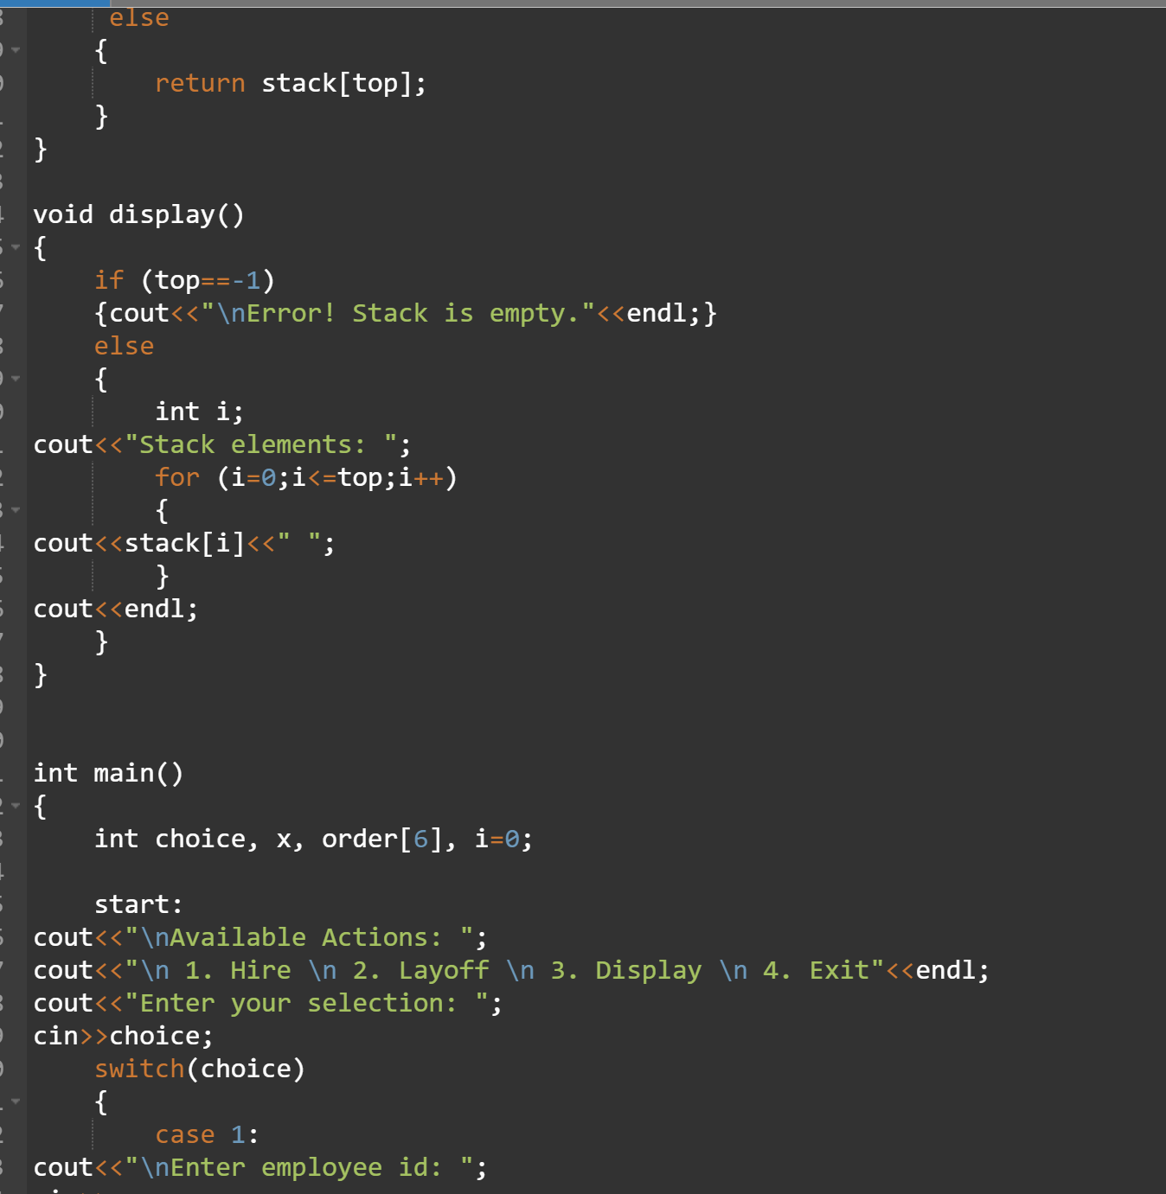

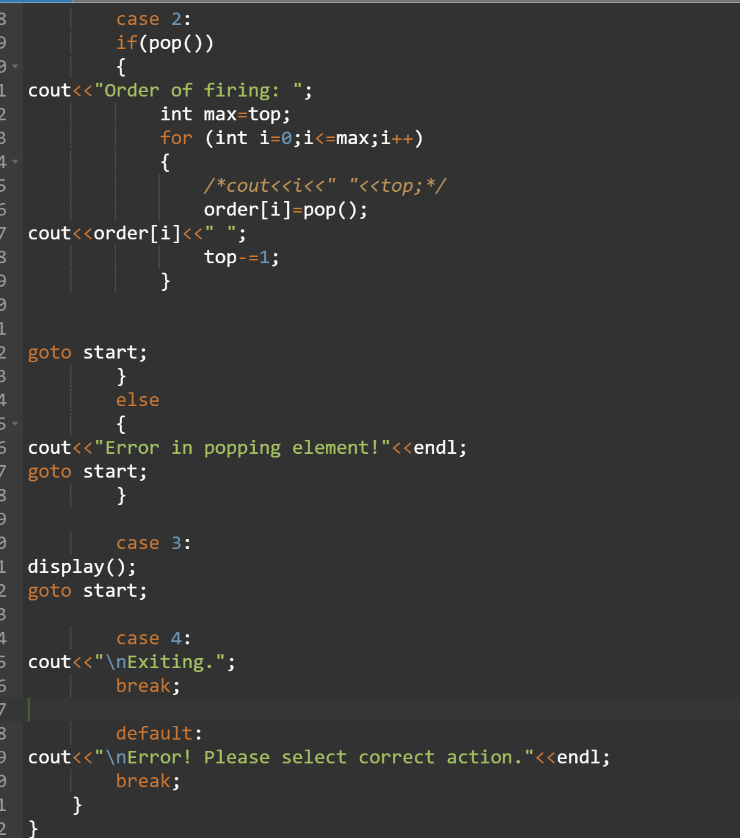
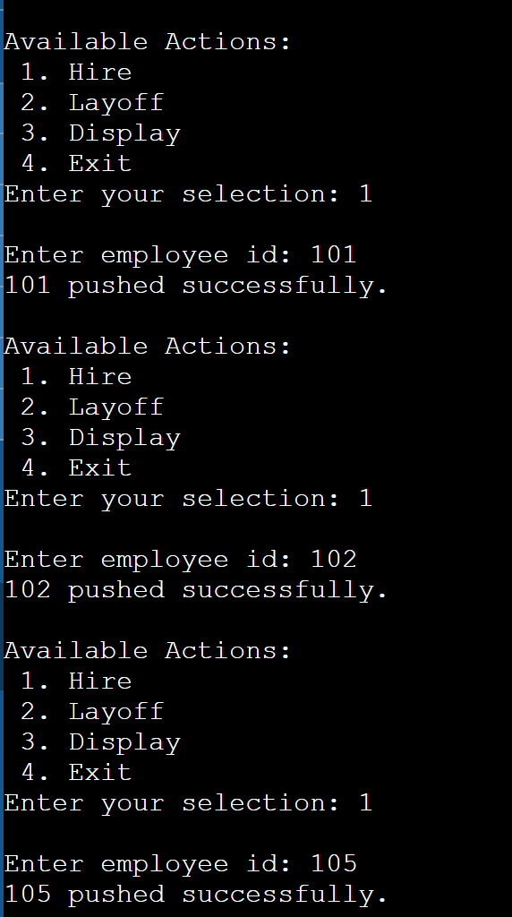
TASK 3
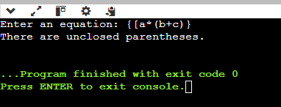

TASK 4
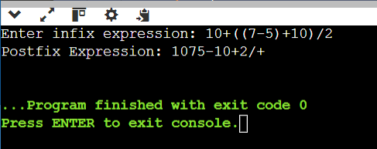
B.3Observations and learning [w.r.t. all tasks]:
(Students are expected to comment on the output obtained with clear observations and learning for each task/ sub part assigned)
B.4Conclusion:
(Students must write the conclusion as per the attainment of individual outcome listed above and learning/observation noted in section B.3)
B.5Question of Curiosity
(To be answered by student based on the practical performed and learning/observations)
Checking for palindrome string
Suppose characters are arriving on a stream reader. Suggest an algorithm to see if the string forms a palindrome. Capitalization, spacing, and punctuation are ignored.

************************

